PRACTICE YOUR ENGLISH - ECOLOGICAL VOCABULARY
Exercises created by students - international class on online learning platform Edmodo
1. Links to exercises:
https://learningapps.org/watch?v=p1h36236317
https://learningapps.org/watch?v=py4dgs8r517
ex 1 created by Italian students
2. Match the expressions to the category: wind, land, river, sea, tornado, planet, ground, hurricane, lake.
EARTH | WATER | AIR

3.Solve the rebus
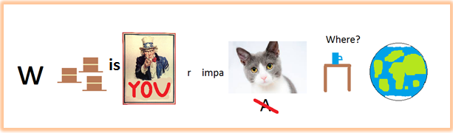
ex 2,3 created by Krzysiek
4. Answer the questions:
- What should you do with the rubbish?
- segregate it,
- burn it,
- throw it everywhere.
- How do plants get water?
- by the leaves when it rains,
- from their roots,
- they don’t need water.
- Who should take care of the Earth?
- adults,
- specialists,
- everyone.
- When we celebrate the DAY OF EARTH?
- the 1st of April,
- the 22nd of April,
- the 26th of May.
- What plants produce?
- nice smell,
- water,
- oxygen.
- What colour is the basket for things made of plastic?
- green,
- blue,
- yellow.
ex 4 created by Francesca
5. Complete the crossword: recycling, pollution, smog, litter, organic, ocean, earth

e
c
o
l
o
g
y

ex 5 created by Kacper
6. Solve the rebus
+ 3
....... + ree = ...?....
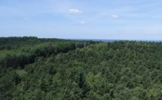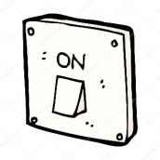
ter + ew + tu + et + stude = ......?......
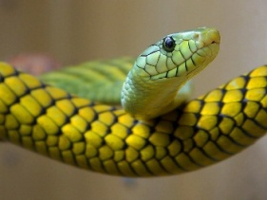
nake + e = ...........?........
ex. 6 created by Justyna
7. What's that? (sky, Sun, forest, water, Earth)
- Blue, we need it in our live, it covers 71% of the Earth:
- Big, hot, it's up in the sky, warms and gives light:
- We live here, a single populated planet in the Universe:
- Big, blue, sometimes dark and sometimes sunlit:
- Green, there are many trees, It houses many animals and plants:
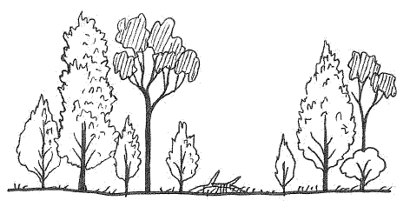
8.What are the contaminants of the environment? (put an x there)
- Solar panel
- Trash
- Car and chimney smog
- Trees and plants
- Bike traffic
- Selective garbage collection

9.What is there in the picture?
- 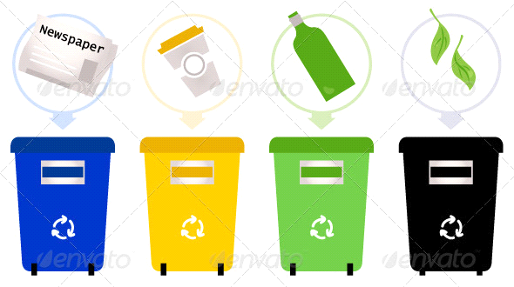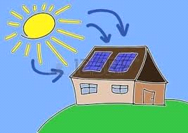
- 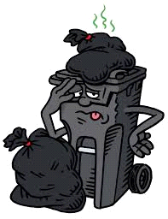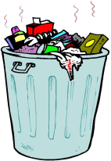

10. What do you think, we call natural disasters? (circle it)
- Tsunami, Earhtquake, Hurricane, Tornado, Avalanche
- Wildfire, melting ice, storm
- Go to school and to get up early
11. Where should you throw the garbage?
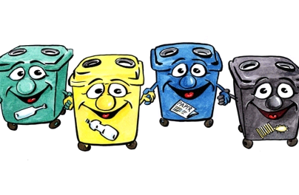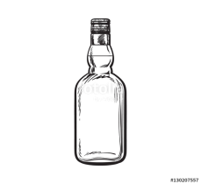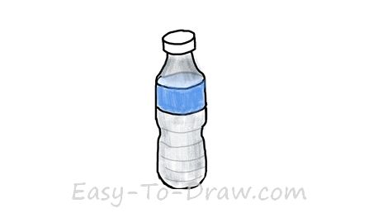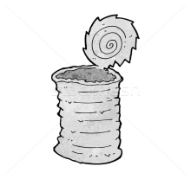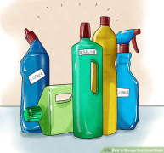
ex 7-11 created by Renata
12.
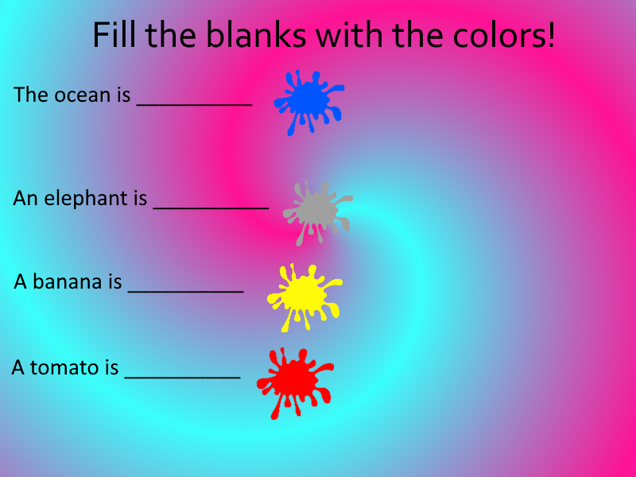
13. Nature - guess the answers:
  - A animal that has very long neck:
  - Slow moving animal that has a shell:
  - This animal loves bananas:
  - World´s fastest land animal:
  - The name of our planet:
  - Striped horse:
  - Hot, dry area of land with a few plants:
  - Water that comes from the sky:
  - A large area of land with trees:
  - formed water, that falls from the sky:
14. Put a word in the gap
- When I got home I opened the ____.
- I looked through the ______ to see outside.
- He opened the lock with ____.
- Sam climbed a ___.
- Matt went to ____ or the place where we study.
- We live on ____.
- _____ is a lesson where we study animals and so on.
- We breath ___.
- The green thing on dirt is ____ .
15. Crossword
1. 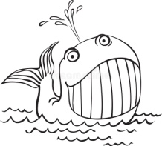 2. 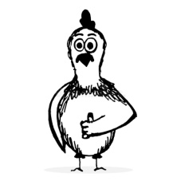 3. 4. 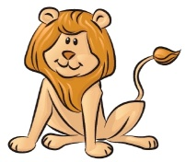 5. 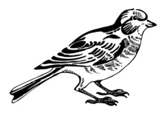
6. 7. 8. 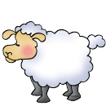 9. 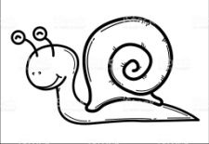 10. 11. 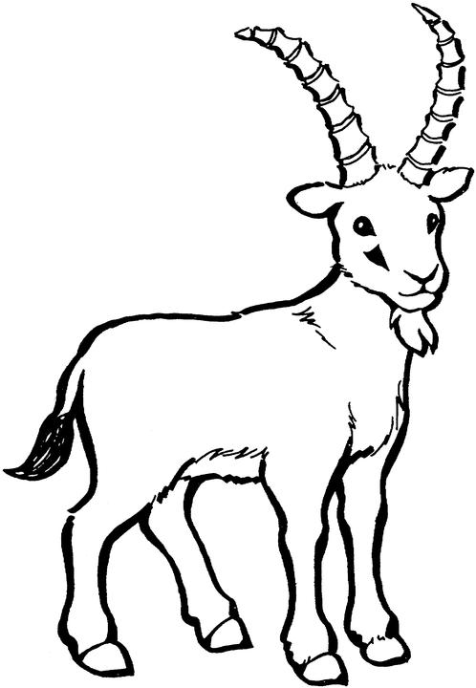 12. 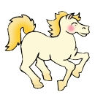 13.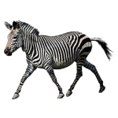 14. j.... 15.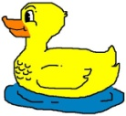
16. 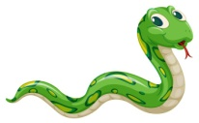 17. 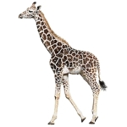 18. 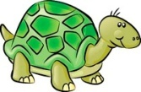 19. 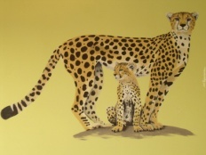

1.
2.
3.
4.
5.
6.
7.
8.
9.
10.
11.
12.
13.
14.
15.
16.
17.
18.
19.
TheCrossword

Secret Message: __________________________
ex 12 - 15 created by students from Estonia

Answer keys
ex. 13.
1. door 2.window 3.keys 4. tree 5. school 6. earth 7. science 8. air 9. grass
ex. 14
 |  |  |  | 1. | W | H | A | L | E
 |  |  | 2. | C | H | I | C | K | E | N
3. | H | I | P | P | O
 |  |  |  | 4. | L | I | O | N
 |  |  | 5. | B | I | R | D
 |  |  |  | 6. | V | E | T
 |  | 7. | E | L | E | P | H | A | N | T
 |  |  |  | 8. | S | H | E | E | P
 | 9. | S | N | A | I | L
 |  | 10. | P | A | N | D | A
 | 11. | G | O | A | T
 |  |  |  | 12. | H | O | R | S | E
 |  |  | 13. | Z | E | B | R | A
 |  |  |  | 14. | J | U | M | P
 |  |  | 15. | D | U | C | K
 |  |  | 16. | S | N | A | K | E
 |  |  |  | 17. | G | I | R | A | F | F | E
18. | T | U | R | T | L | E
 |  | 19. | C | H | E | E | T | A | H

